From: https://www.davidstockmanscontracorner.com/roaring-back-my-eye-part-1/?mc_cid=32c0554a7a&mc_eid=23bf5d4e64
To wit, the tax cut was passed in August 1981 long before the GDP buckled in 1982 under the brutal impact of Paul Volcker’s unavoidable monetary castor oil, which temporarily took interest rates to 21% and unemployment to 10%. But all the while during the dark winter of 1981-1982 the Gipper did stoutly resist calls for Keynesian stimulus and government funded jobs and public works programs, and even continued to demand deep spending cuts, to the point of shutting down the government in the fall of 1982 over budget busting continuing resolutions.
Alas, when Volcker had sufficiently dispatched the inflationary price-wage-price spiral that had reached a fever pitch in 1980-1981, and could therefore take his foot off the monetary brakes, and with the added impetus of lower marginal tax rates and meaningfully reduced regulatory obstacles, the allegedly slow-witted private sector did leap into an accelerated pace of economic activity. It needed no cattle prod or sugar high from the monetary and fiscal authorities.
As shown in the chart below, the year-over-year gains in real final sales—the most stable measure of real economic growth—ranged between 5% and 6% per annum for nine quarters running, until rising debt and interest rates finally brought the expansion cycle to a halt in 1990.
But if ever any proof was needed that the supply side drives the economy and that ['that' perhaps should be 'via' -FNC] Say’s Law, which essentially holds that supply leads the economy and creates its own demand from the income generated by production, the so-called Reagan Recovery is dispositive. All the while during the near decade long expansion displayed below, interest rates were normal and ample in real terms and there was no fiscal spending stimulus whatsoever.
Supply Side Recovery, 1983-1990
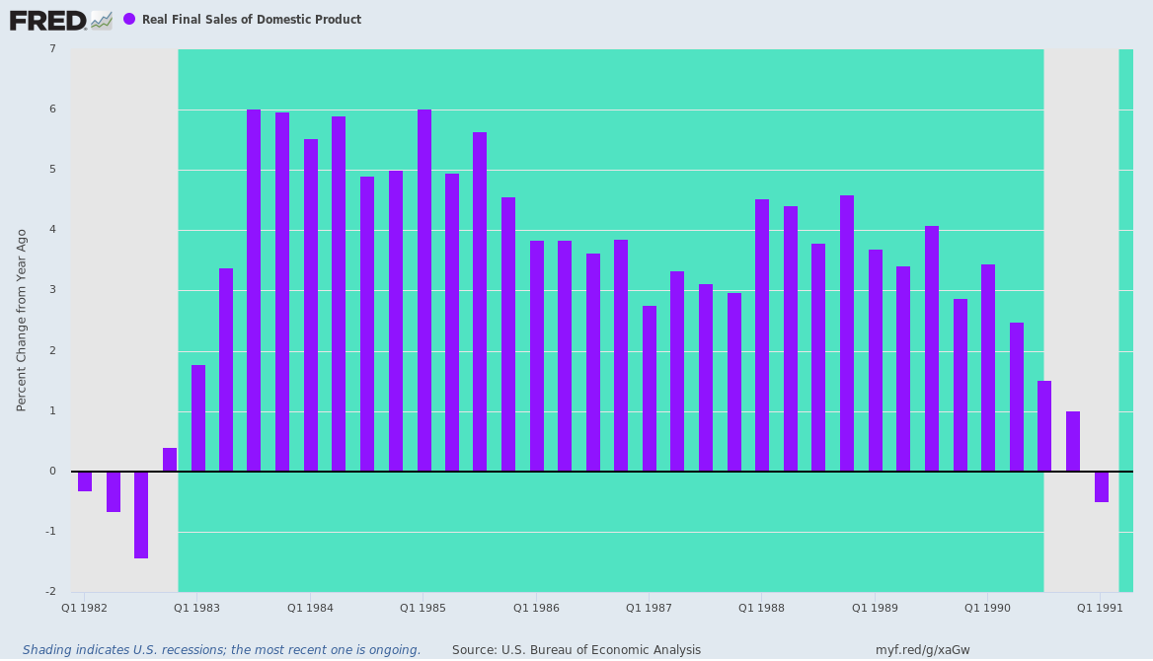
For want of doubt, here is the cumulative growth of nominal GDP, total Federal spending and transfer payment spending over the course of the eight year Supply Side Recovery cycle. Obviously, the private sector led the growth parade, with today’s go to stimulant—transfer payments—trailing well behind.
Cumulative Growth, Q1 1983 to Q3 1990:
- Nominal GDP: +73.2%;
- Federal expenditures: +54.8%;
- Federal transfer payments: +48.2%.
In a word, it was a Say’s Law recovery, not a Washington stimulated simulacrum of growth fueled by government spending and money printing that merely pulls future activity forward [out from the 'future' toward the 'present' -FNC] , at best. Even B-Dud is now admitting that per the confession to be essayed in Part 2.
GDP Versus Government Spending And Transfer Payment Growth, Q1 1983 to Q3 1990
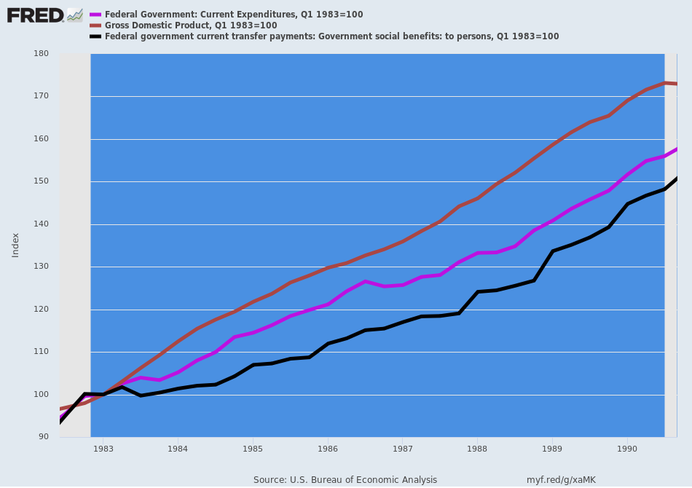
We have focused on the 1980s supply side recovery in order to debunk the “roaring back” nonsense that emanated from the Donald and his shills and cheerleaders upon this morning’s [2020] Q3 GDP release. In a word, what actually came roaring back was $3.5 trillion worth of government stimulus that worked its way through the spending capillaries of the national economy, not a genuine supply-side upturn in sustainable growth.

